Keppel Bay Boatyard
Certificate of Environmental Support

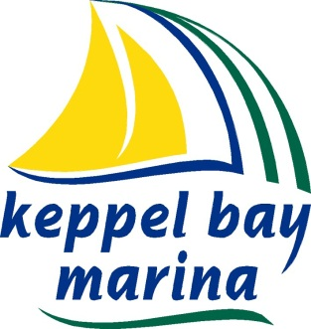

Keppel Bay Marina cares about the environment,
We ask all boat owners, contractors and visitors to do the same.

We clean and maintain our work areas regularly.

We do our best to make sure particles or wastewater from boat cleaning or maintenance work do not fall into or drain to the foreshores or the marine environment.

We make sure activities such as sanding, grinding, high-pressure cleaning and painting
do not pollute the water, ground or air with particles, dust or fumes.

Abrasive blasting and grinding is prohibited in the marina.

We make sure materials such as fuels, oils, cleaners and paints are correctly handled and stored safely and with care to prevent pollution of the ground, air and water.

We require our customers and contractors who use the facilities to be aware of their environmental responsibilities – specifically, litter and other wastes and wastewaters from recreational, maintenance, repair and cleaning activities must not pollute the water, ground or air.

We keep material to clean up spills in an accessible place where it is clearly labelled and ready for use.

We are aware noise is a nuisance, so we do our best to minimise loud music, excessive revving of engines, hammering and sanding.

We require you to use biodegradable soaps and cleaning products.

We are always looking for new opportunities to reduce the amount of waste we dispose of to landfall. We encourage reuse and recycling.

We encourage suggestions and new ideas which will improve the environment.

